Assignment 5
List Iterators

Description

Using the following class diagram, create an iterator for your linked list class created in Assignment 4. You may modify your linked list class if desired to emulate the STL iterators as shown in class.

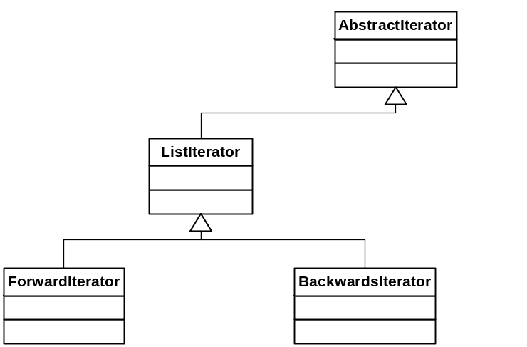

AbstractIterator Methods
MoveNext
Reset
IsDone
GetCurrent

